Voice of the Moorlands
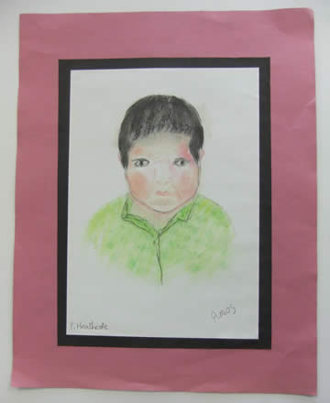
This Park Art follow-on project, again supported by PDSDF, concentrated on the how people in the Staffordshire Moorlands talk and tell their stories.

